XG Boost
Data Set: IRIS Data Set
Install xgboost – At Anaconda prompt type
pip install xgboost
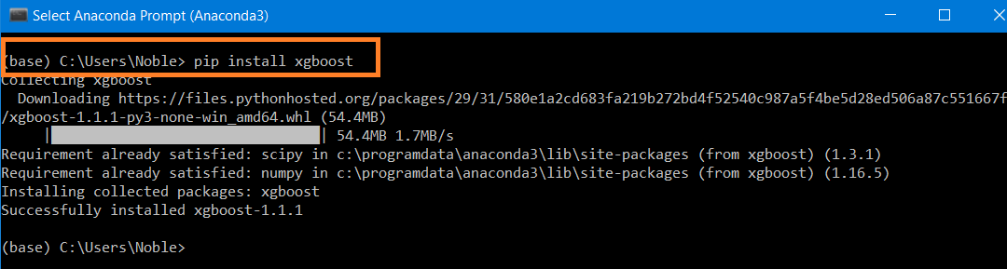

pip list ( to check if it install or not)

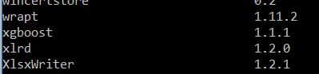

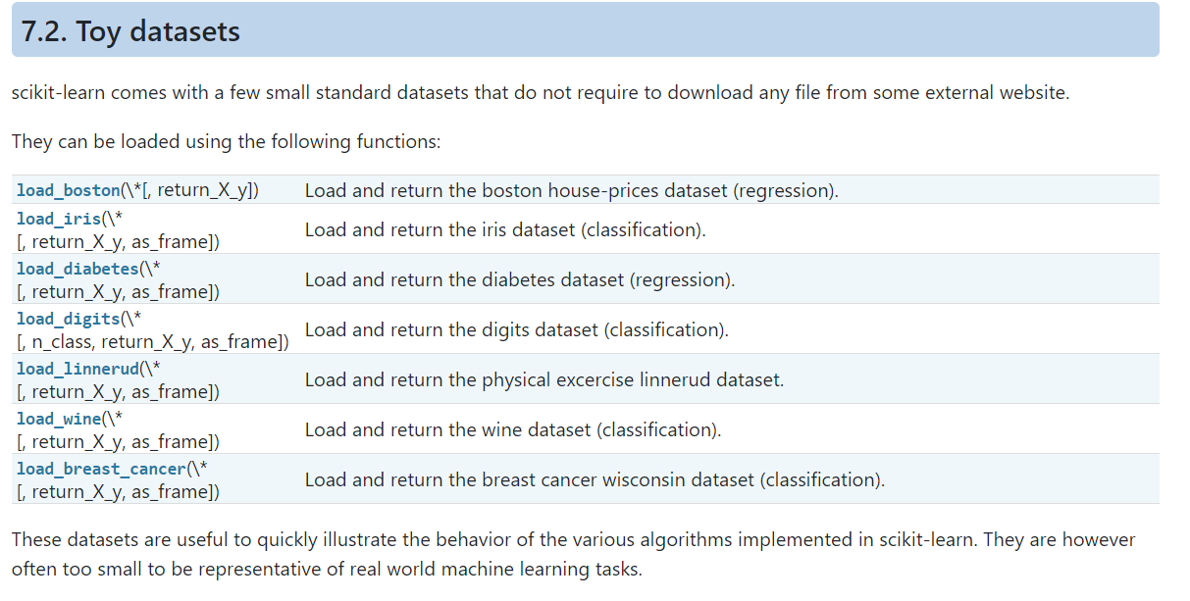
Load IRIS Data set (Default Dataset in sklearn)
from sklearn.datasets import load_iris
iris= load_iris()
display (iris)

View all other default data sets in sklearn
from sklearn import datasets
dir(datasets)

Display Wine Data set
import pandas as pd
import numpy as np
from sklearn.datasets import load_wine
wine= load_wine()
display (wine)

Display Wine data as Data Frame
import pandas as pd
pd.DataFrame(wine['data'])

View IRIS Data set Target values
print (list(iris.target_names))

View Data
print(iris)

View Data
print(iris.data)
print(iris.target)

view source (x) data as data frame
import pandas as pd
print (pd.DataFrame(iris.data))

view target (y) data as data frame
print (pd.DataFrame(iris.target))

Number of Rows and Number of Features

numSamples,numFeatures = iris.data.shape
print('Number of Records-', numSamples)
print ('Number of columns-',numFeatures)

Train Test Split
from sklearn.model_selection import train_test_split
x_train,x_test, y_train,y_test = train_test_split(iris.data, iris.target, test_size = .2)
print (x_train.shape)
print (x_test.shape)
print (y_train.shape)
print (y_test.shape)

Create Train and Test Model – xgboost
XGBoost comes with its own class for storing datasets called DMatrix. It is a highly optimized class for memory and speed. That's why converting datasets into this format is a requirement for the native XGBoost API
DMatrix is an internal data structure that is used by XGBoost, which is optimized for both memory efficiency and training speed.

import xgboost as xgb
train = xgb.DMatrix (x_train,label =y_train)
test = xgb.DMatrix (x_test,label =y_test)

Create Parameters
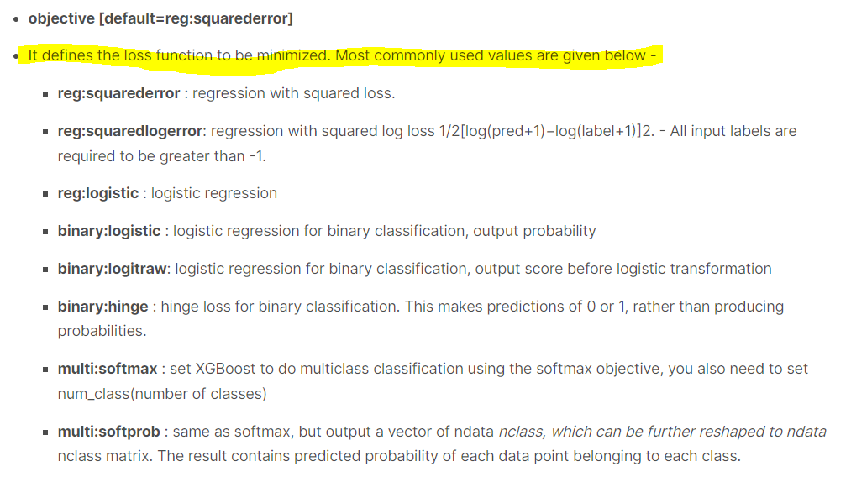
eta [default=0.3, alias: learning_rate] - It is analogous to the learning rate

param = {'max_depth':4, 'eta':0.3, 'objective': 'multi:softmax', 'num_class': 3}
epochs =10

Create Model
model= xgb.train (param, train, epochs)
display (model)
Predictions
predictions= model.predict(test)
print ('prediction')
print (predictions)
print ()
print ('y_test')
print (y_test)

Accuracy Score
from sklearn.metrics import accuracy_score
display (accuracy_score (y_test,predictions))

Create Decision Tree
from sklearn.tree import DecisionTreeClassifier
classifier = DecisionTreeClassifier (criterion = 'entropy')
classifier.fit (x_train,y_train)
print (classifier)

Predictions
y_pred= classifier.predict(x_test)
print (y_pred)

Accuracy Score
print('Accuracy Score')
print (accuracy_score (y_test,y_pred),'\n')
Random Forest Classifier

from sklearn.ensemble import RandomForestClassifier
RF= RandomForestClassifier (n_estimators = 100,criterion = 'entropy')
RF.fit (x_train,y_train)
print (RF)

Prediction and Accuracy

RF_y_pred= RF.predict(x_test)
RF_y_pred
print('Accuracy Score')
print (accuracy_score (y_test,RF_y_pred),'\n')

Hyperparameter Optimization with X G Boost

Import Libraries
import numpy as np
import pandas as pd
import os
import warnings
warnings.filterwarnings("ignore")

Load Data Set
os.chdir('C:\\Noble\\Training\\Top Mentor\\Training\Data Set\\')
df=pd.read_csv('Churn_Modelling.csv')
display (df)

Remove string columns and Dependent variable to create a co-relation matrix
dfcorr = df.drop ('Geography', axis =1).drop ('Gender', axis =1).drop ('Exited', axis =1)
dfcorr = dfcorr.iloc[:,3:]
display (dfcorr)

Display Co relation Matrix

display (dfcorr.corr())

Plot Heat Map
import seaborn as sns
import matplotlib.pyplot as plt
plt.figure(figsize=(11,6))
sns.heatmap(dfcorr.corr(),annot=True,cmap="RdYlGn")
plt.show()

Create X
X=df.iloc[:,3:13]
display (X)
Create Y
Y=df.iloc[:,13]
display (Y)

Check distinct Geography values before onehot encoding
print (X['Geography'].value_counts())

One hot encoding, store one hot encoded values in Variable geography

geography=pd.get_dummies(X['Geography'],drop_first=True,dtype = int)
display (geography.head(10))

One hot encoding- Gender Column

gender=pd.get_dummies(X['Gender'],drop_first=True, dtype = int)
display (gender.head(10))

Drop Geography and Gender Column from X

X=X.drop(['Geography','Gender'],axis=1)
display (X)

Concatenate Gender and Geography (one hot encoded data set) columns with X.

X=pd.concat([X,geography,gender],axis=1)
display (X)

Different Parameters for XG Boost
params={
"learning_rate" : [0.05, 0.10, 0.15, 0.20, 0.25, 0.30 ] ,
"max_depth" : [ 3, 4, 5, 6, 8, 10, 12, 15],
"min_child_weight" : [ 1, 3, 5, 7 ],
"gamma" : [ 0.0, 0.1, 0.2 , 0.3, 0.4 ],
"colsample_bytree" : [ 0.3, 0.4, 0.5 , 0.7 ]
}

Create XG Boost Classifier,
# n_jobs=-1 , This ensure all the CPU capacity will be used to create this model. This signifies the number of jobs to be run in parallel, -1 signifies to use all processor.
# verbose=3, Provide the messages or execution status
# ROC-AUC-Receiver Operating Characteristic – Area Under Curve similar to f1-score

from sklearn.model_selection import RandomizedSearchCV, GridSearchCV
import xgboost
classifier=xgboost.XGBClassifier()
random_search=RandomizedSearchCV(classifier,param_distributions=params,n_iter=100,scoring='roc_auc',n_jobs=-1,cv=10,verbose=3)

Display all Scoring values

from sklearn import metrics
display (", ".join(metrics.get_scorer_names()))

Function Timer used to check execution duration

def timer(start_time=None):
if not start_time:
start_time = datetime.now()
return start_time
elif start_time:
thour, temp_sec = divmod((datetime.now() - start_time).total_seconds(), 3600)
tmin, tsec = divmod(temp_sec, 60)
print('\n Time taken: %i hours %i minutes and %s seconds.' % (thour, tmin, round(tsec, 2)))

Fit Random Search CV

from datetime import datetime
start_time = timer(None) # timing starts from this point for "start_time" variable
random_search.fit(X,Y)
timer(start_time) # timing ends here for "start_time" variable

Display X Data set
display (X.head())

Best Parameters
display (random_search.best_params_)

Print Best Parameter: Mention the best parameters used to create this model

display (random_search.best_estimator_)

Create XG Boost with best paraments.

classifier=xgboost.XGBClassifier(base_score=0.5, booster='gbtree', colsample_bylevel=1,
colsample_bynode=1, colsample_bytree=0.3, gamma=0.1, gpu_id=-1,
importance_type='gain', interaction_constraints='',
learning_rate=0.1, max_delta_step=0, max_depth=5,
min_child_weight=1, monotone_constraints='()',
n_estimators=100, n_jobs=4, num_parallel_tree=1, random_state=0,
reg_alpha=0, reg_lambda=1, scale_pos_weight=1, subsample=1,
tree_method='exact', validate_parameters=1, verbosity=None,use_label_encoder=False )

Cross Validation
from sklearn.model_selection import cross_val_score
score=cross_val_score(classifier,X,Y,cv=10)

Print result from each cross validation
print (score)

Print Mean and standard deviation

print (score.mean())
print (score.std())

Create Model

classifier = classifier.fit(X,Y)
print (classifier)

Prediction

y_pred = classifier.predict(X)
display (y_pred)

Accuracy Score
from sklearn.metrics import accuracy_score
print (accuracy_score(Y,y_pred))

Create XG Boost in the Normal Way
Train Test Split

from sklearn.model_selection import train_test_split
x_train,x_test,y_train,y_test = train_test_split(X,Y,test_size= 0.2)
print (X.shape)
print (Y.shape)
print (x_train.shape)
print (y_train.shape)
print (x_test.shape)
print (y_test.shape)

Create Model

classifier=xgboost.XGBClassifier()
classifier.fit(x_train,y_train)
print (classifier)

Prediction for Test Data Set
y_pred = classifier.predict (x_test)
print (y_pred)

Accuracy Score
from sklearn.metrics import accuracy_score
print (accuracy_score (y_test,y_pred))

Classification Report

from sklearn.metrics import classification_report
print(classification_report (y_test,y_pred,zero_division=0))

Confusion Matrix
from sklearn.metrics import confusion_matrix
cm = confusion_matrix (y_test,y_pred)
print (cm)

